**PRANAV SANDEEP RAIKAR**

**D10A43**

**UNIX LAB**

**EXPT 4**

A)Execution of Process management commands like ps,pstree,nice,kill,pkill,killall,xkill,fg,bg,pgrep,etc.

**ps**-[ps command](https://www.digitalocean.com/community/tutorials/linux-ps-command) is short for ‘Process Status’. It displays the currently-running processes. However, unlike the top command, the output generated is not in realtime.

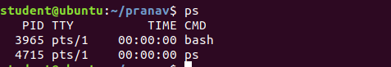



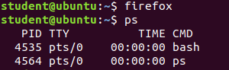

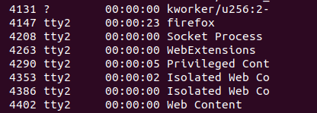



**Pstree-**pstree is a Linux command that shows the running processes as a tree. It is used as a more visual alternative to the ps command. The root of the tree is either init or the process with the given pid. It can also be installed in other Unix systems

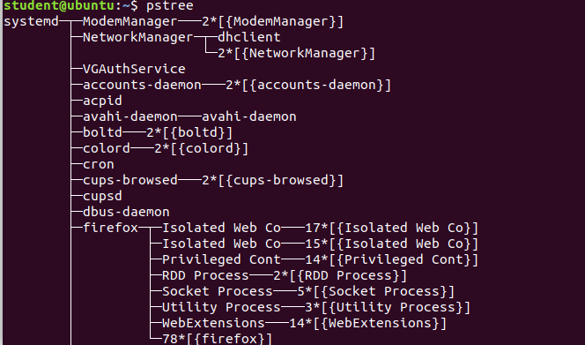

**Nice**-The nice command lets you run a command at a priority lower than the command's normal priority. The Command parameter is the name of any executable file on the system. If you do not specify an Increment value the nice command defaults to an increment of 10.

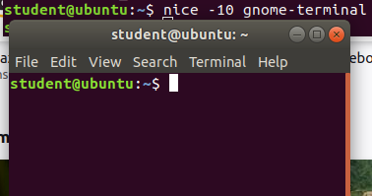

**Kill-**To stop a process in Linux, use the 'kill’ command. [kill command](https://www.digitalocean.com/community/tutorials/kill-command-in-linux) sends a signal to the process.

There are different types of signals that you can send. However, the most common one is ‘kill -9’ which is ‘SIGKILL’.

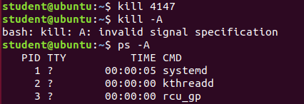

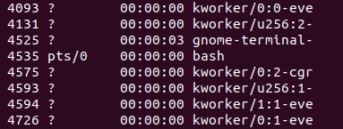

**Pkill-**The pkill command uses name of the process instead of PID number. Signal can be send to a process either by typing full name or partial name.While specifying partial name, the specified name should be within first 15 characters of the process name.

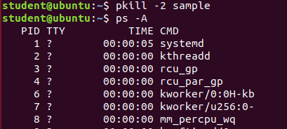

**Killall-**The killall command cancels all processes that you started, except those producing the killall process. This command provides a convenient means of canceling all processes created by the shell that you control.



**Xkill-**xkill is a command-line utility that can kill the undesired windows on the user's screen. Basically, xkill force the X server to close the connection to the client. This utility kills the programs without providing PID with a command**.**

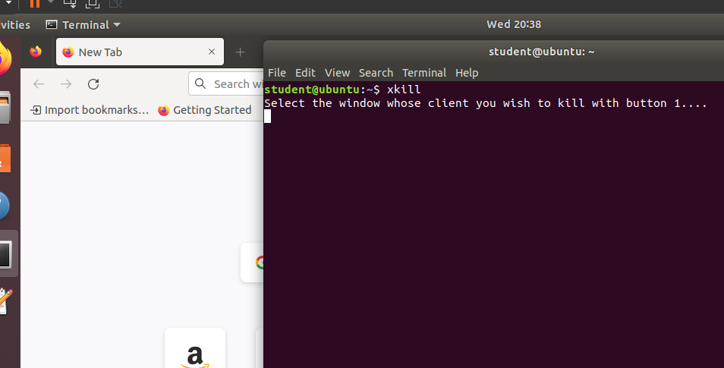

**After clicking the window to close the windows is closed**

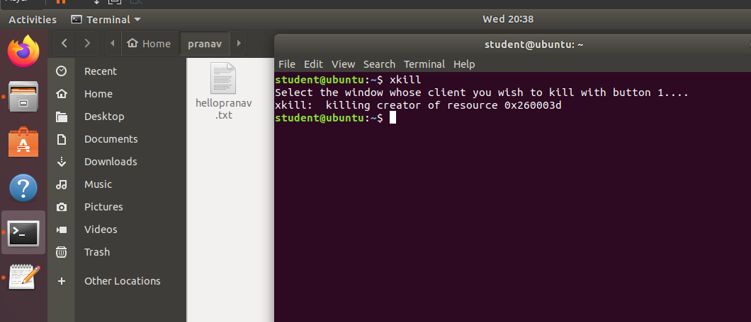

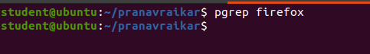

**pgrep** looks through the currently running processes and lists the process IDs which match the selection criteria to stdout.

**Fg-**Using the fg command to place a job into the foreground removes the job's process ID from the list of those known by the current shell environment. The /usr/bin/fg command does not work when operating in its own command execution environment, because that environment does not have applicable jobs to manipulate.

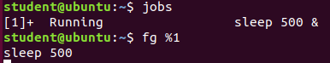

**Bg-**bg command in linux is used to place foreground jobs in background. This command is used to put the mentioned job in background. In the below screenshot, we do following :

1.We use [jobs command](https://www.geeksforgeeks.org/process-control-commands-unixlinux/) to list all jobs

2.We create a process using sleep command, we get its ID as 1.

3.We put it in background by providing its ID to bg

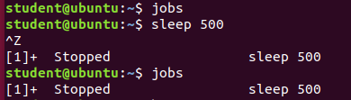

**Pgrep-**The grep command searches for the pattern specified by the Pattern parameter and writes each matching line to standard output. The patterns are limited regular expressions in the style of the ed or egrep command. The grep command uses a compact non-deterministic algorithm.

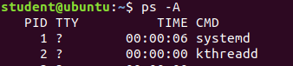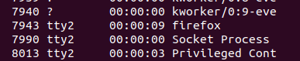

**Execution of Memory Management Commands**

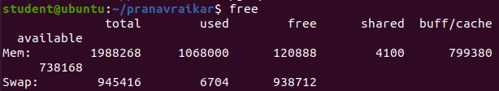

In LINUX, there exists a command line utility for this and that is **free** command which displays the total amount of free space available along with the amount of memory used and swap memory in the system, and also the buffers used by the kernel.

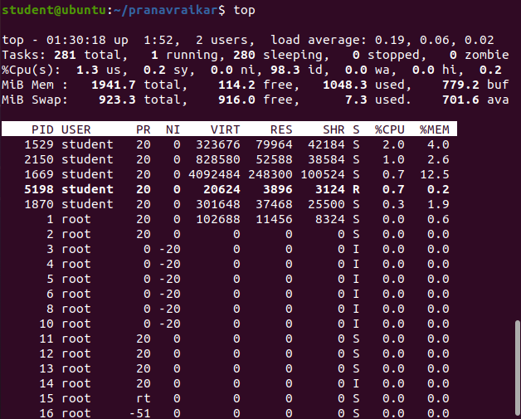

**top** command is used to show the Linux processes. It provides a dynamic real-time view of the running system.

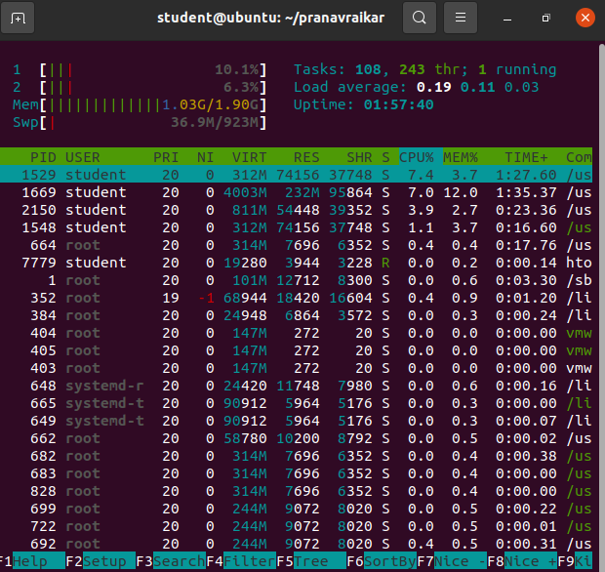

In a nutshell, **htop** is **a useful command-line tool in the Linux environment to determine the cause of load by each process**. It is similar to Task Manager in the Windows OS environment.

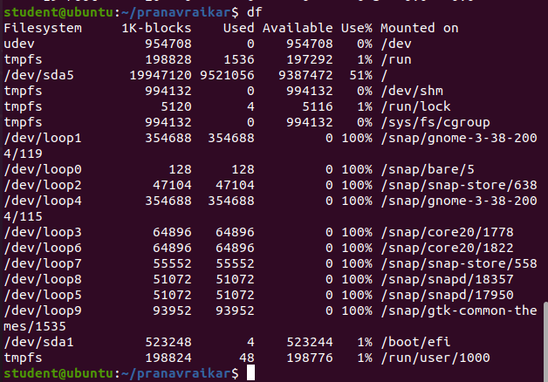

The **df** command **displays the amount of disk space available on the filesystem with each file name's argument**.



The **du** command **displays the number of blocks used for files**. If the File parameter specified is actually a directory, all files within the directory are reported on. If no File parameter is provided, the du command uses the files in the current directory.

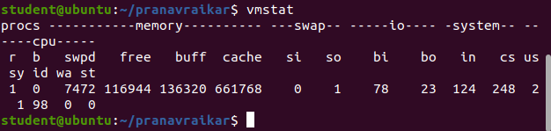

The **vmstat** command **reports statistics about kernel threads in the run and wait queue, memory, paging, disks, interrupts, system calls, context switches, and CPU activity**. The reported CPU activity is a percentage breakdown of user mode, system mode, idle time, and waits for disk I/O.

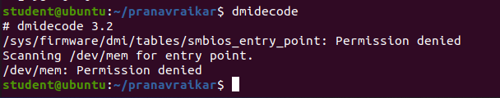

**dmidecode** also referred as **Desktop Management Interface table decoder, record data from DMI table and produce it in human readable format**.

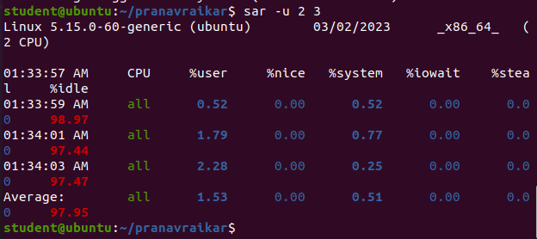

The **sar** command **produces system utilization reports based on the data collected by sadc** . As configured in Red Hat Enterprise Linux, sar is automatically run to process the files automatically collected by sadc .

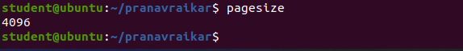

The pagesize command **prints the size, in bytes, of a page of memory, as returned by the getpagesize subroutine**. Provided for system compatibility, this command is useful when constructing portable shell scripts.